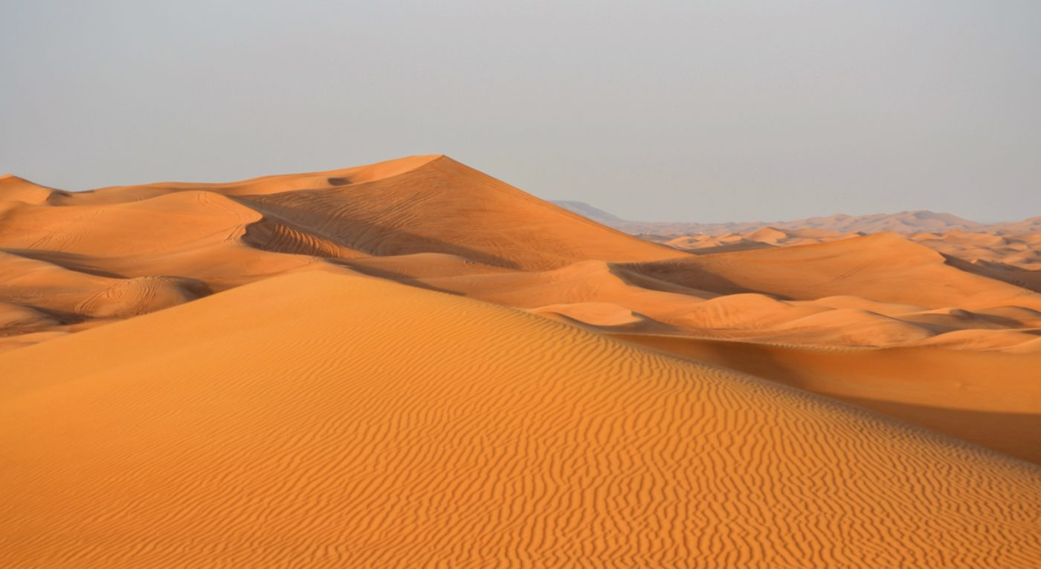

Importance of desert :

The **Desert** Biome is an **important** part of Earth because many animals live in it and it is a source of sand. Also, a lot of oil is often found under many **deserts**. ... Several species of vultures also live in the **desert** to scavenge on animal remains. The **Desert** Biome is also **important** because it has its own ecosystem.

The dry condition of **deserts** helps promote the formation and concentration of **important** minerals. Gypsum, borates, nitrates, potassium and other salts build up in **deserts** when water carrying these minerals evaporates

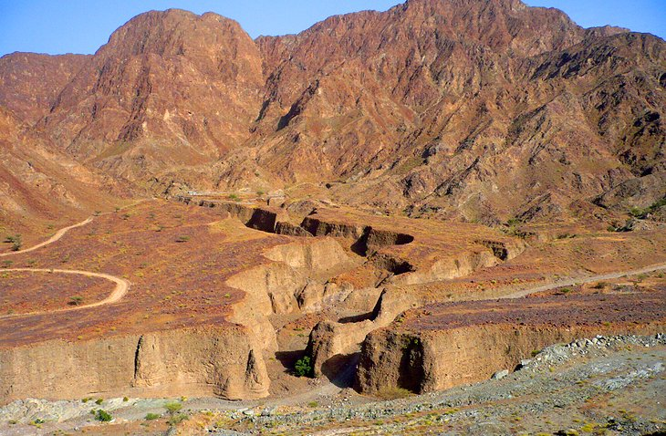

Importance of mountains

**Mountains** play a significant role in providing water and food supply to the millions of people in the world

Climbers and tourists visit them for the scenery. Water authorities make reservoirs and pump the water to towns and cities

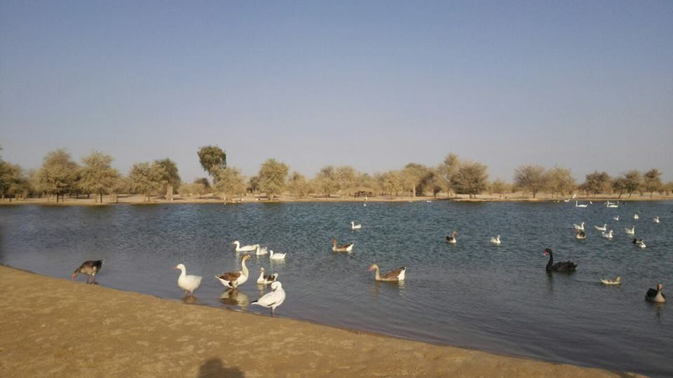

Importance of lake:

the great **lakes** give us benefit such as providing water, food for human use,water purification to support ecosystems

Healthy **lakes** and their shores not only provide us with a number of environmental **benefits** but they influence our quality of life and they strengthen our economy. Proper **lake** function can ease the impact of floods and droughts by storing large amounts of water and releasing it during shortages.